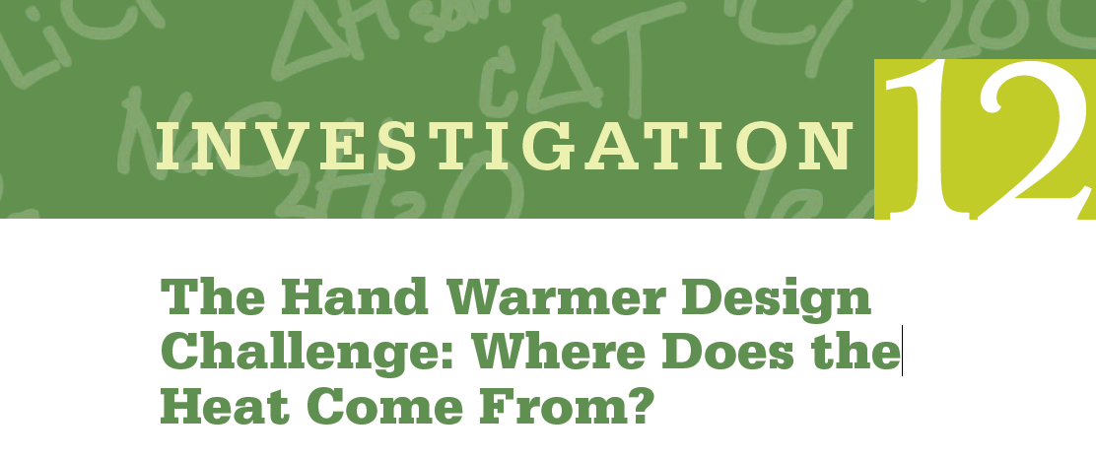
■Central Challenge: Use chemistry to design an effective, safe, environmentally benign, and inexpensive hand warmer. The ideal hand warmer increases in temperature by 20 ºC (but no more) as quickly as possible, has a volume of about 50 mL, costs as little as possible to make, and uses chemicals that are as safe and environmentally friendly as possible. Carry out an experiment to determine which substances, in what amounts, to use in order to make a hand warmer that meets these criteria.
■Context for This Investigation
Have your fingers ever been so cold they felt numb? Wouldn’t it be great if you could generate heat to warm your hands up anytime you want to? That’s exactly what a “hand warmer” does. Hand warmers are small packets that people put inside gloves or mittens on cold days to keep their fingers warm. They are very popular with people who work outside in winter or engage in winter sports. One type of hand warmer contains water in one section of the packet and a soluble substance in another section. When the packet is squeezed the water and the soluble substance are mixed, the solid dissolves and the packet becomes warm.

Safety and Disposal
The solids and resulting solutions in this investigation are potential eye and skin irritants. Calcium chloride can cause skin burns. Ammonium nitrate is a powerful oxidizer that must be kept away from ignition sources and is quite toxic on ingestion. Students must wear gloves and splash-proof safety goggles and must use caution throughout the experiment and adhere to all safety guidelines. If solutions are spilled on skin, wash with copious amounts of water. Follow the normal procedures for chemical waste disposal at your institution. If it is allowed in your location, solutions may be safely diluted and poured down the drain.

■Prelab Guiding Questions/Simulations
An animation showing the dissolution of an ionic compound on the particulate level can be found on the website Chemistry Experiment Simulations and Conceptual Computer Animations:
http://group.chem.iastate.edu/Greenbowe/sections/projectfolder/flashfiles/thermochem/solutionSalt.html
- Describe the changes you observe in the animation, including changes in the bonds and particulate attractions and changes in the amount of disorder in the system.
- When sodium chloride is dissolved in water, the temperature of the resulting solution is lower than the temperature of the water before the salt dissolves. How can this result be explained based on the bond breaking and bond making that is occurring?
- Why do some salts, such as sodium chloride, dissolve spontaneously even though the process is endothermic overall?
- When some ionic salts are dissolved in water, the temperature of the resulting solution is higher than the temperature of the water before the salt dissolves. What do you think determines whether the resulting solution is cooler or warmer than the starting water?

■Explanation to Strengthen Student Understanding
Breaking bonds and particulate attractions absorb energy from the surroundings, while forming new bonds and particulate attractions release energy to the surroundings. When an ionic solid dissolves in water, ionic bonds between cations and anions in the ionic solid and hydrogen bonds between water molecules are broken, and new attractions between water molecules and anions and water molecules and cations are formed. The amount of energy required to break these bonds and form new ones depends on the chemical properties of the particular anions and cations. Therefore, when some ionic solids dissolve, more energy is required to break the cation–anion bonds than is released in forming the new water– ion attractions, and the overall process absorbs energy in the form of heat. When other ionic compounds dissolve, the converse is true, and the bond making releases more energy than the bond breaking absorbs, and therefore the process overall releases heat. When heat is absorbed, the enthalpy change, q, is endothermic, and the enthalpy change is positive. When heat is released, the change is exothermic, and the value of q is negative. The entropy change of solution formation is always positive, regardless of whether it is endothermic or exothermic, because solutions are much more disordered than are the pure solute and solvent from which they are made. This positive entropy change is thermodynamically favorable. A calorimeter is a container used to determine the enthalpy change that occurs during a process. Calorimetry is an important technique in chemistry, and chemists often work with devices called bomb calorimeters. For home or classroom experiments, however, a coffee cup calorimeter is sufficient to make rough measurements.

Procedure
Calorimeter Calibration Procedure
Place a 100.0 mL sample of water in a clean, dry 150 mL beaker. Heat with occasional stirring to approximately 50 ºC. Remove the beaker from the hot plate and place on the lab bench. Meanwhile, place exactly 100.0 mL of cool water (approximately 20 ºC) in the clean, dry calorimeter. Measure the temperature of the hot water and the cold water and record, then immediately pour the entire hot water sample into the calorimeter and quickly put on the cover. Wait 15 seconds then take a temperature reading. Repeat this determination twice
Hand Warmer Design Procedure
Use the following steps to design a procedure for this investigation:
- Safety and Environmental Impact: Obtain the MSDS for your three solids from your teacher. Review each one, making notes about safety concerns, necessary precautions, and disposal.
- Cost: Rank the solids you are given from least to most expensive.
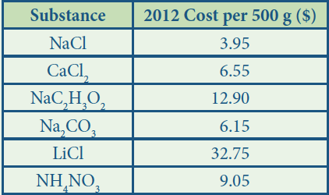
- Heat of Solution: Work with your group to design a procedure to compare the solids in terms of the heat released or absorbed when they dissolve and include what materials and equipment you will use. You must include the safety precautions you will take.
Important Tips:
- Be sure to keep detailed records of the amounts of substances used and the starting and ending temperature as you will need it later to determine the amount of solid to use in your hand warmer.
- You will receive a maximum of 10 g of each solid for this part.

Data Collection and Computation
In this experiment, you will collect data that will allow you to calculate the change of enthalpy of dissolution (also called the “heat of solution,” with symbol ΔH_{soln}, and units of kJ/mol solute) occurring in aqueous solution. The data necessary to calculate the heat of solution can be obtained using a calorimeter. Calorimeter Constant Determination: According to the law of conservation of energy, energy cannot be created or destroyed, only changed from one form to another or transferred from one system to another. The temperature change observed when water or any substance changes temperature can be a result of a transfer of energy from the substance to the surroundings (in which case the temperature of the substance decreases) or the surroundings to the substance (in which case the temperature of the substance increases). When hot and cold water are mixed, the hot water transfers some of its thermal energy to the cool water. The law of conservation of energy dictates that the amount of thermal energy lost (or the enthalpy change) by the hot water, q_{hot}, is equal to the enthalpy change of the cool water, q_{cold}, but opposite in sign, so q_{hot} = –q_{cold}. The enthalpy change for any substance is directly related to the mass of substance, m; the specific heat capacity (a substance-specific constant), c; and the temperature change, ΔT. The relationship is expressed mathematically in the equation q = mcΔT. The specific heat capacity of water is 4.184 J/ºC•g.

1a. Calculate the enthalpy change of the cool water using the equation q_{hot} = m_{hot}cΔT_{hot}. Assume that the density of water is exactly 1 g/mL. Is this an endothermic or exothermic process? Explain.

1b. Calculate the enthalpy change of hot water using the equation q_{cold} = m_{cold}cΔT_{cold}. Assume that the density of water is exactly 1g/mL. Is this an endothermic or exothermic process? Explain.

1c. These amounts are not equal because the calorimeter (the coffee cups) absorbs some of the thermal energy transferred by the hot water. Thus under the real conditions observed in the laboratory the law of conservation of energy equation becomes q_{hot} = –(q_{cold} + q_{cal}), where q_{cal} is the enthalpy change of the calorimeter. Use this equation to calculate the enthalpy change of the calorimeter.

1d. The calorimeter constant, C, is the heat absorbed by the calorimeter per degree of temperature change, C = q_{cal}/ΔT_{cal}. Assuming the starting temperature of the calorimeter is the same as the cold water, calculate the calorimeter constant in units of joules per degree Celsius.

2. The solid and water, considered together, have a certain amount of internal energy as a function of the bonds that exist in the solid and in the water. The solution that is produced as a result of the dissolving has a different amount of internal energy than the solid and water did because the arrangement of particles and the bonds and attractions between the particles in the solution are different bonds and particulate attractions than the arrangement of particles and the bonds and attractions between the particles in the solid and water. The difference in energy, q_{soln}, is the reason for the difference in the thermal energy of the two systems (solid and pure water versus solution), with symbol q_{rxn}. Just as with the hot and cold water in the calorimeter constant determination, q_{soln} and q_{rxn} are equal in magnitude and opposite in sign, q_{rxn} = –q_{soln}. And just as in that case of the cold and hot water mixing, the calorimeter will also experience an enthalpy change during the solution formation process. To account for this enthalpy change, the relationship is adjusted to q_{soln} = –(q_{rxn} + CΔT) where C is the calorimeter constant determined above. This difference in thermal energy of the system before and after solution formation, q_{soln}, can be calculated using the relationship qrxn = mcΔT, where m is the total mass of the solution and c is the specific heat capacity of the solution and ΔT is the temperature change of the solution. It is important to note that we will assume that the heat capacity of the solutions is the same as pure water but in reality the solutions do not have exactly the same heat capacity, and this assumption affects the accuracy of this determination.
Using this information, calculate q_{soln} and q_{rxn} for all three solids you tested for your hand warmer.

3. By convention, scientists report enthalpy changes for dissolution (and many other processes) in units of kilojoules per mole of solute dissolved. Using your values of qsoln, calculate the enthalpy in units of kilojoules per mole. This quantity has the symbol ΔHsoln.

4. Based on the cost information provided, and your experimental work and calculations, select which chemical you believe will make the most cost-effective hand warmer. The hand warmer you are designing needs to increase in temperature by 20ºC. Calculate the amount of the compound you selected that would be required for a hand warmer that meets this requirement.

Argumentation and Documentation
Write a paragraph in which you describe all of the factors you considered as well as explain your rationale for choosing one chemical and not each of the other chemicals studied in this experiment. Your paragraph should start with a claim sentence that clearly states your choice and the amount of substance to use. The claim should be followed by evidence from your experiment and cost and safety analysis. The paragraph should conclude with reasoning, explaining how your evidence supports your claim.

